#### **Project Overview**

In this capstone project, you will create a comprehensive automated deployment pipeline for a web application on an AWS EC2 instance running Ubuntu using Ansible. You will follow best practices for playbooks and roles, implement version control, document and maintain your code, break down tasks into roles, write reusable and maintainable code, and use dynamic inventory scripts. This project will culminate in a fully functional deployment, demonstrating your mastery of Ansible for infrastructure automation.

#### **Project Objectives**

* Set up an AWS EC2 instance as a worker node.
* Implement Ansible playbooks and roles following best practices.
* Use version control to manage Ansible codebase.
* Document Ansible roles and playbooks.
* Break down deployment tasks into reusable roles.
* Write reusable and maintainable Ansible code.
* Use dynamic inventory scripts to manage AWS EC2 instances.
* Deploy a web application on the EC2 instance.

#### **Project Components and Milestones**

### **Milestone 1: Environment Setup**

**Objective**: Configure your development environment .

**Tasks**:

* Install Ansible and Git on your local machine or control node.

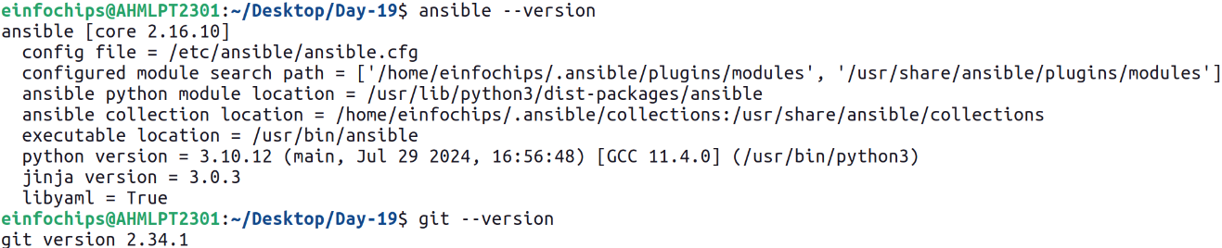

### **Milestone 2: Create Ansible Role Structure**

**Objective**: Organize your Ansible project using best practices for playbooks and roles.

**Tasks**:

* Use Ansible Galaxy to create roles for web server, database, and application deployment.

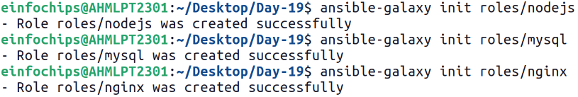

### **Milestone 3: Version Control with Git**

**Objective**: Implement version control for your Ansible project.

**Tasks**:

* Initialize a Git repository in your project directory.

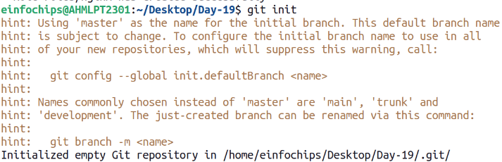

* Commit and push initial codebase to a remote repository.

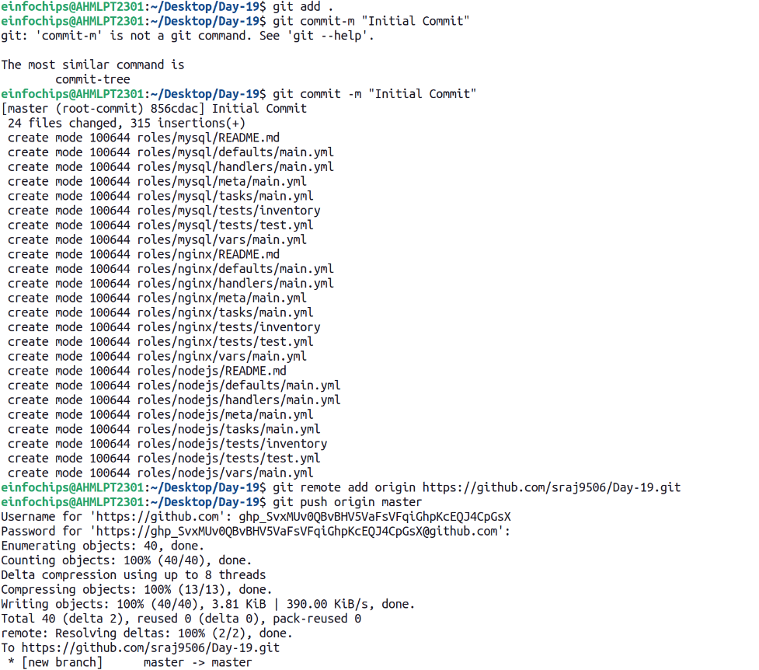

### **Milestone 4: Develop Ansible Roles**

**Objective**: Write Ansible roles for web server, database, and application deployment.

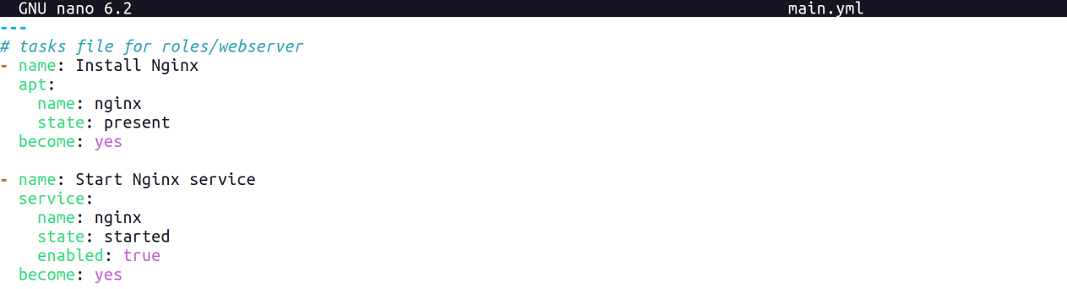



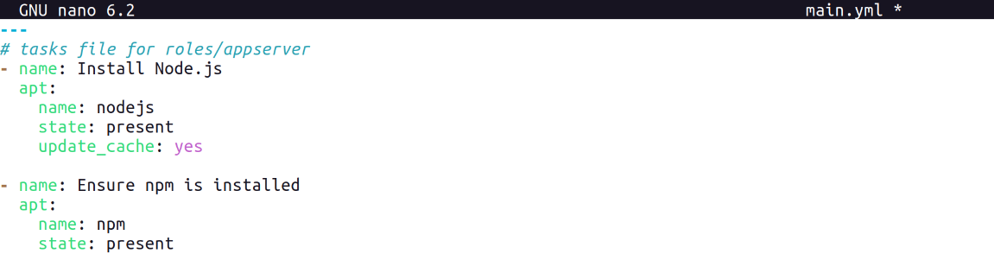

### 

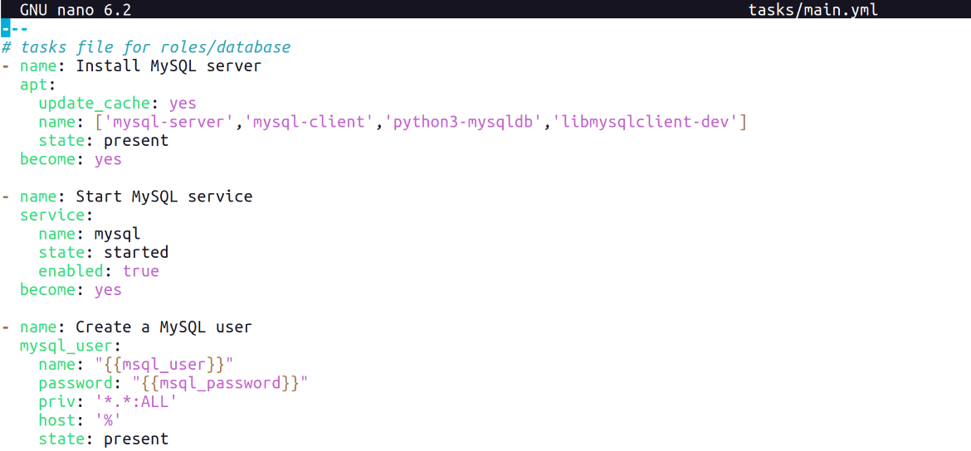

### **Milestone 5: Dynamic Inventory Script**

**Objective**: Use dynamic inventory scripts to manage AWS EC2 instances.

**Tasks**:

* Write a Python script that queries AWS to get the list of EC2 instances.

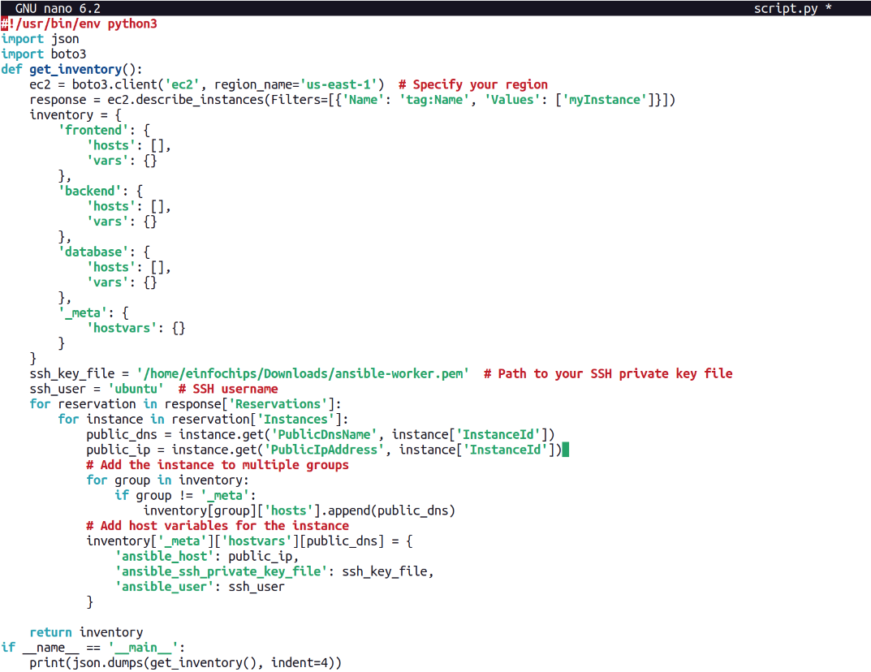

* Format the output as an Ansible inventory.

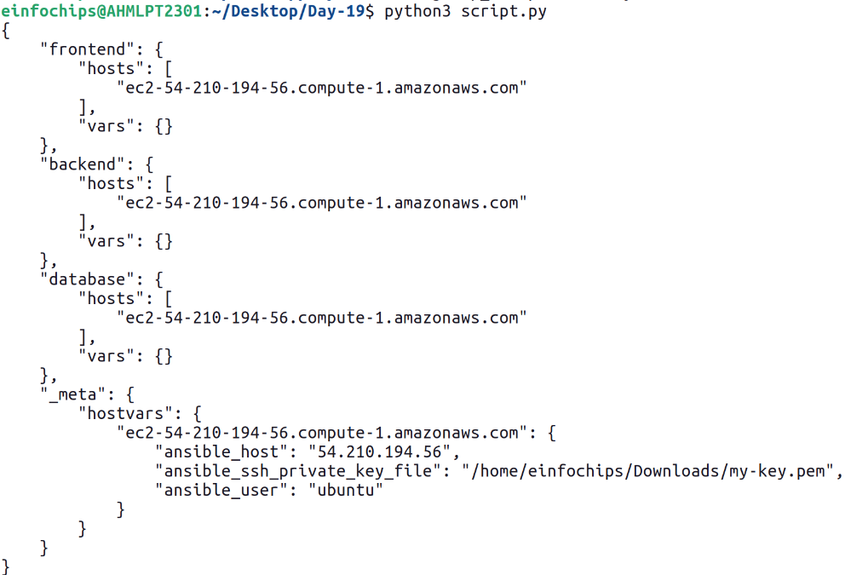

### **Milestone 7: Playbook Development and Deployment**

**Objective**: Create and execute an Ansible playbook to deploy the web application.

**Tasks**:

* Develop a master playbook that includes all roles.

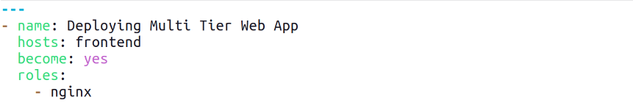

* Define variable files for different environments.



* Execute the playbook to deploy the web application on the EC2 instance.

